Name: Mantasha Shehzadi
Section A
Registration Number: FA24B1-SE-033
Github username: shehzadimantasha-hue
Ubuntu username: shehzadimantasha
Cloud Computing
Assignment:
Task1:
<github-username>@ubuntu
Docker compose ps command:
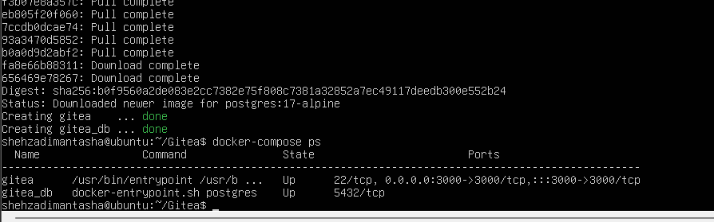
Task 1.1
task1_gitea_running.png
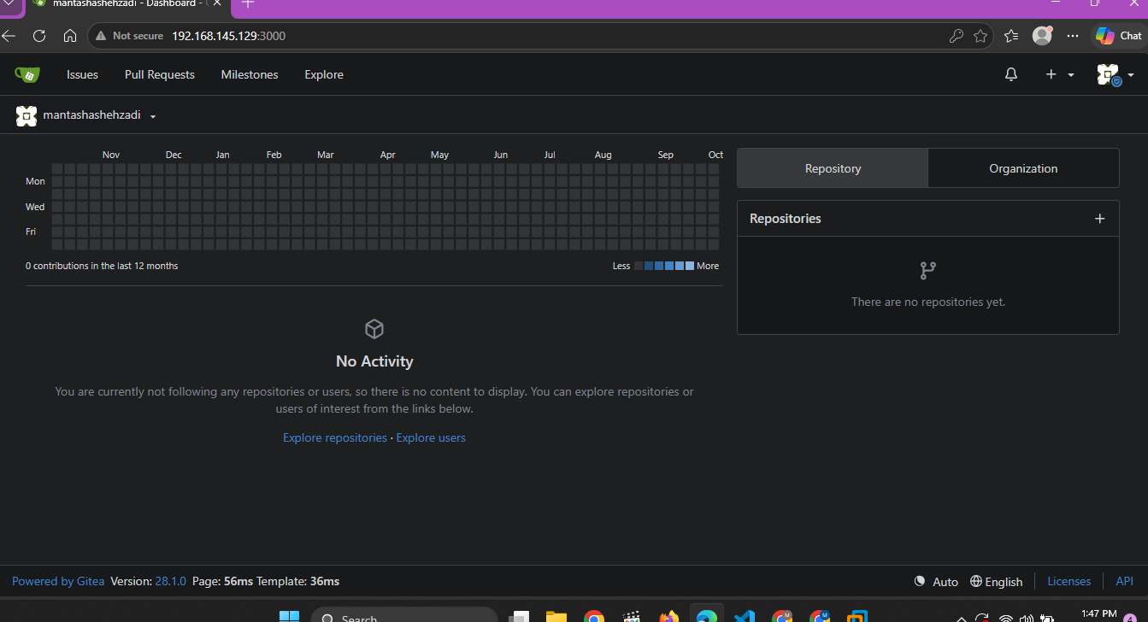
Task 1.2
Task1_gitea_push.png
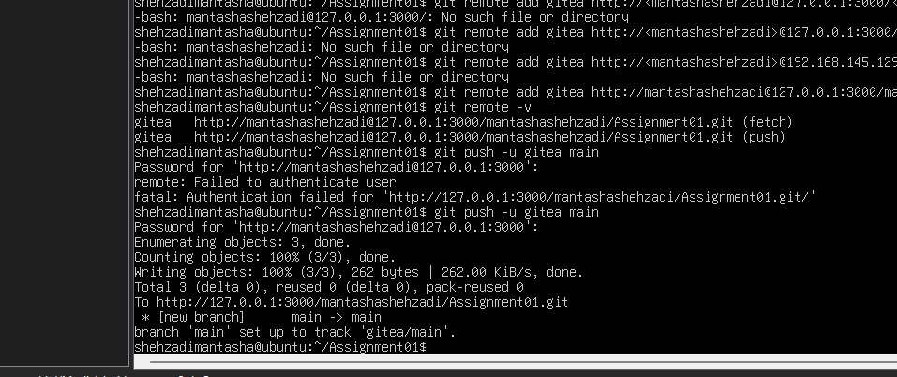
Task 1.3
task1_gitea_repository.png:
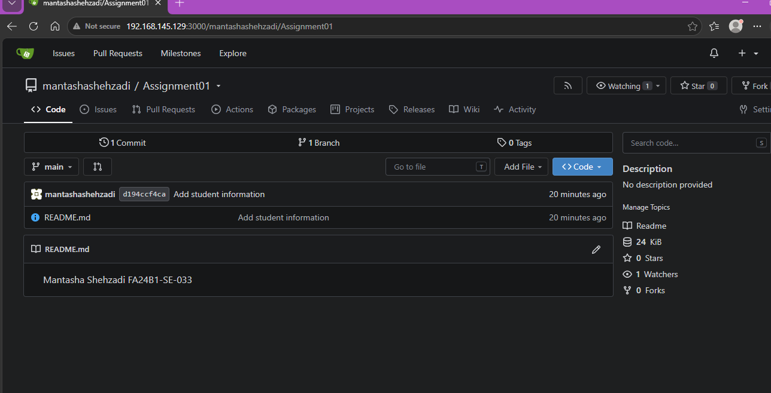
Task 2:
Task 2.1
task2_remotes.png
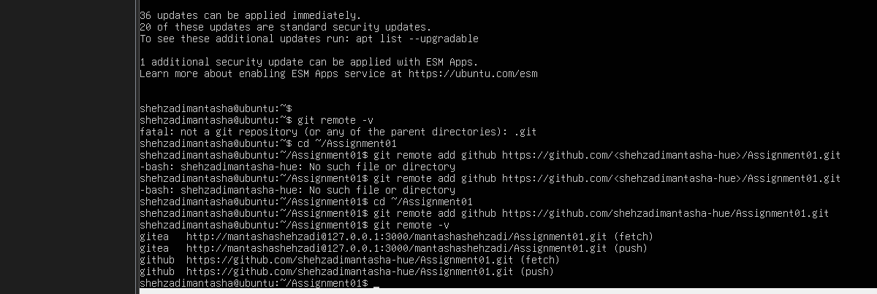
Task 2.2
task2_github_push.png

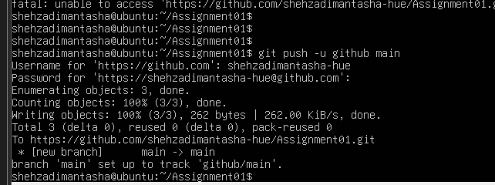
Task 2.3
task2_github_repository.png
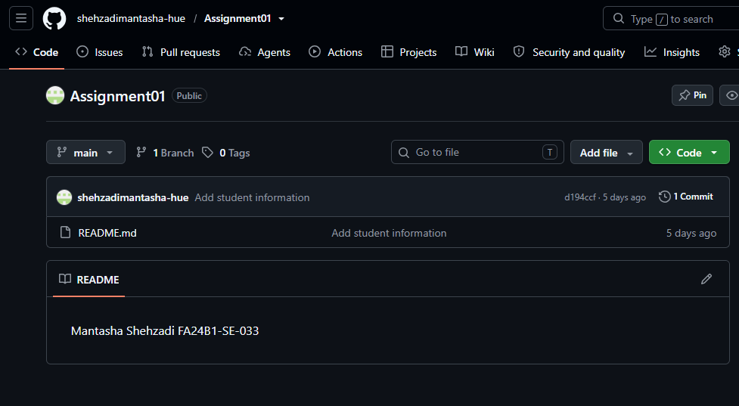
Task 3
Task 3.1
task3_lfs_setup.png
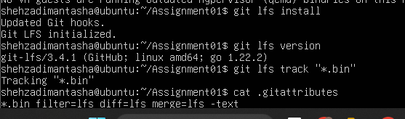
Task 3.2
task3_lfs_files.png
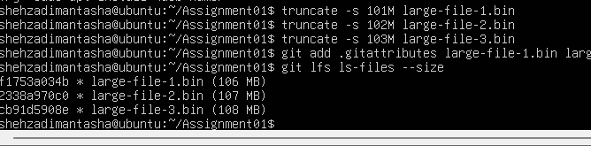
Task 3.3
task3_lfs_push.png
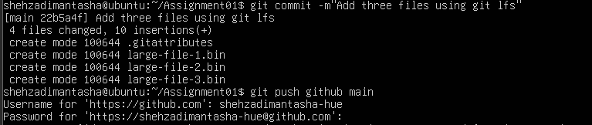
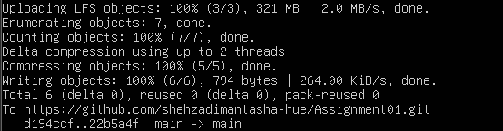
Task 4
Task 4.1
task4_pages_repository.png
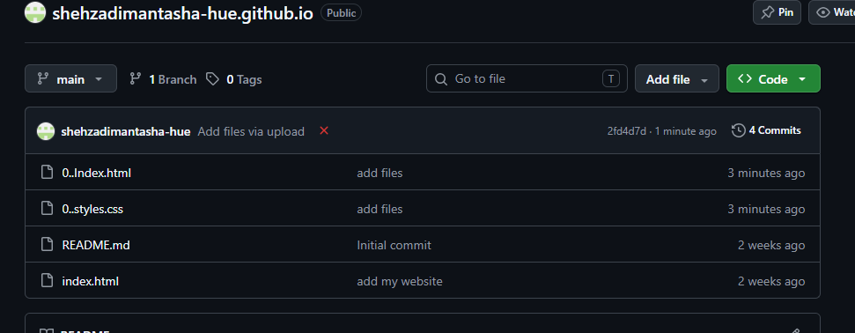
Task 4.2
Task4_pages_deployment.png
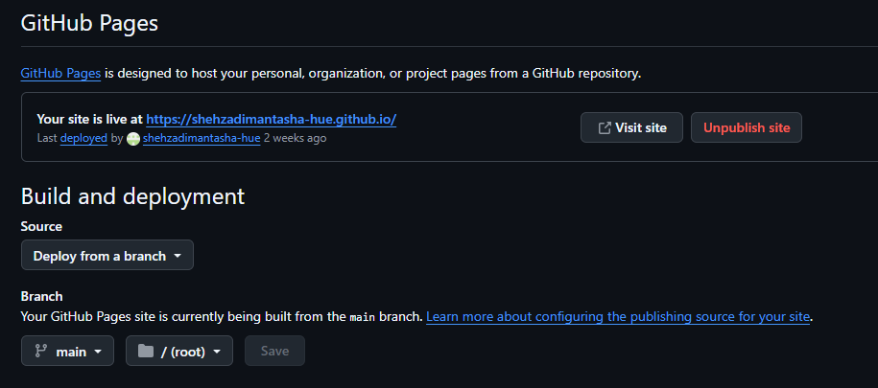
Task 4.3
task4_portfolio_live.png
